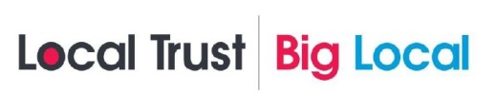
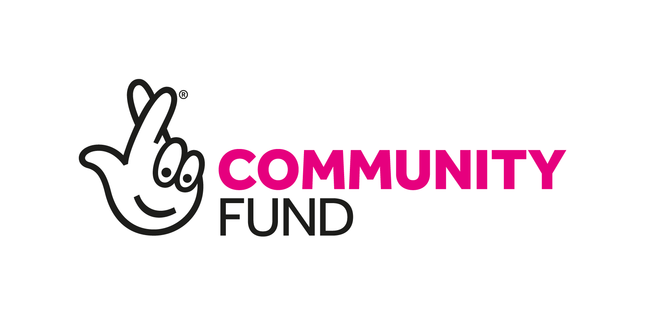
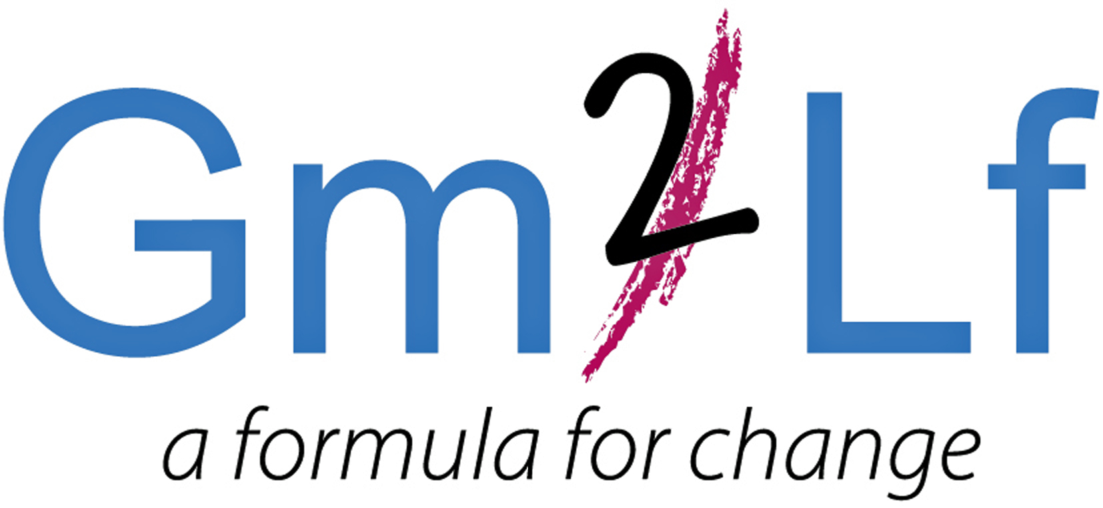

GM2LF Big Local First Steps Enterprise Fund
Application Guidance

What is Grace Mary to Lion Farm (GM2LF) Big Local
In 2014, £1m for a 10-year period was allocated to residents living in the area of Grace Mary to Lion Farm (GM2LF). The lottery money is being given out by Local Trust, a charity which delivers Big Local. Big Local is about bringing together all the local talent, ambitions, skills and energy from individuals, groups and organisations, who want to make the area of Grace Mary to Lion Farm an even better place to live.

Following consultation and research the five key themes that the GM2LF Big Local Partnership seeks to address in the area are:
- Our Community
- Our Environment
- Our Finance
- Our Learning
- Our Wellbeing

In addition to the themes we designated some Big Local budget to Social Investment. Our understanding of Social Investment is that it is a mechanism through which we can both achieve the social impact we desire, but also have a financial return on our funding.

For more information, please read the current GM2LF Big Local Plan (2017 – 2020) which can be found at: www.gm2lf.org

First Steps Enterprise Fund
To support in addressing the priorities under the Social Investment theme grants are currently available for not-for profit, voluntary and community groups and social enterprises active and delivering services in the Grace Mary to Lion Farm area. (Please see area map overleaf).

How much funding is available?
Groups can bid for up to £10,000

Grants are available for enterprising activities and projects which must demonstrate that they meet at least three of the social impact outcomes within the following outcome areas:

- Arts, heritage, sports and faith
- Citizenship and community
- Environment
- Finance
- Housing and local facilities
- Mental health and well-being
- Employment, training and education
- Family, friends and relationships

Funding can be used for either capital expenditure (e.g. equipment, furniture, materials, etc) or revenue costs (e.g. staff wages, venue hire costs and utilities costs). Funding can be used for expanding existing activities or developing new activities that enhance the quality of resident’s lives in the Big Local area.

Funding is not available for individuals, however if you have an exciting project idea and are not involved in a group, please complete an expression of interest form. The partnership would like to hear from you and there may be an opportunity to link in with other groups and projects.

Application Process
- Complete and submit the application form to the GM2LF Big Local Partnership.
- Only one application per organisation can be made at any time.
- Applications have no deadline dates for submission. You can send your form at any time.
- Applications will be considered at a GM2LF Big Local Partnership meeting which are held monthly.
- You may apply for any amount within the period of April 2019 – 28th February 2020.
- Successful and unsuccessful applicants for full applications will be notified within 14 days of the relevant Partnership Board Meeting.
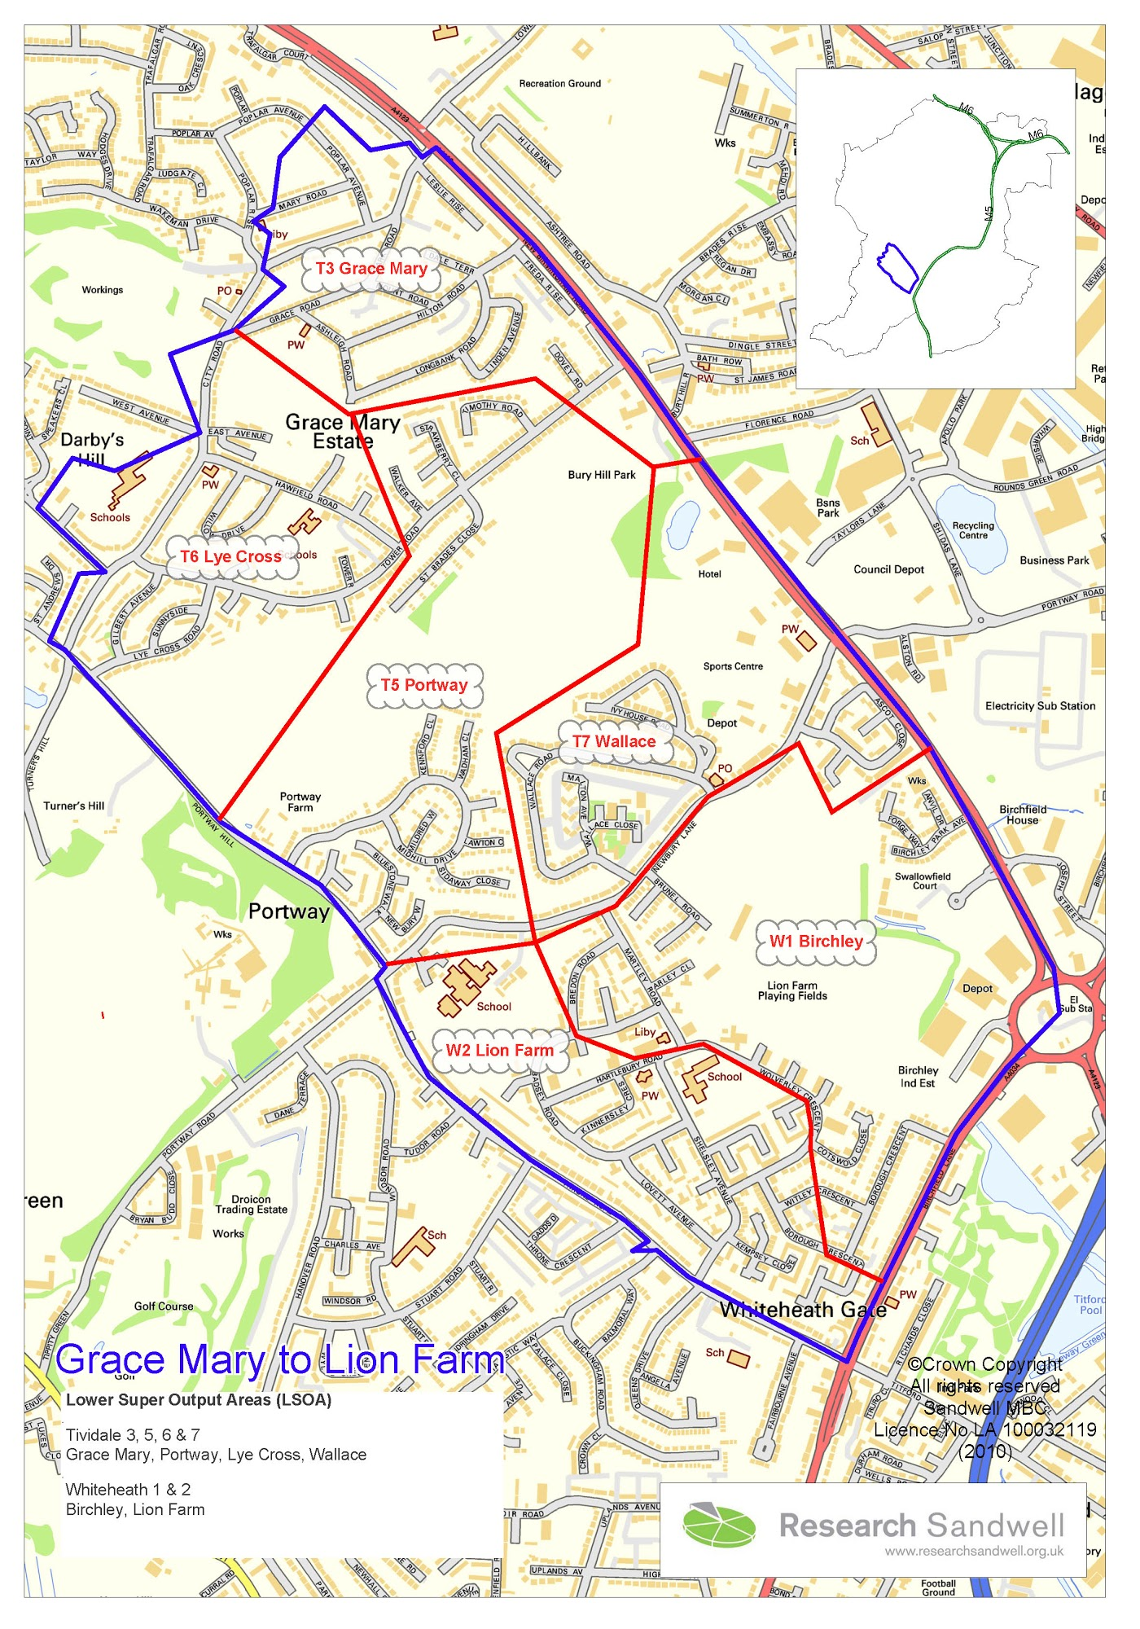
Important Points to Consider when Making an Application
- When applying for a grant, preference will be given to those applicants who can demonstrate how they meet the Big Local outcomes and benefit the residents of the Area.
- Your application must demonstrate both a social impact and a financial return on the funding amount requested.
- If your application involves contact with children or vulnerable adults you will need to satisfy us that all the required DBS checks have been carried out.
- If applying towards a larger project all other funding must be in place or you must evidence how you intend to secure other funding.
- If your application is successful you will be required to have spent the funding and complete a monitoring and evaluation form twelve months after the funding has been received. This form will include a spend breakdown, and we reserve the right to also ask for receipts/invoices.
- Successful applicants will also be expected to acknowledge and display GM2LF Big Local on all publicity relating to the funded project.
- Funding will not be provided on a retrospective basis and organisations should not commit themselves to the project before any final decision is made.
- If your application is successful you will receive 2 copies of a Grant Agreement which will specify any conditions regarding your project. You will need to return a signed copy before any funds are released.
- Decisions made by the Partnership Board are final.
- If your application is successful the grant will be issued via BACS by Sandwell Council of Voluntary Organisations (SCVO). (GM2LF Big Local’s Local Trusted Organisation).
- Please send your application form to: Helen Trueman, Lion Farm Action Centre, The Vicarage, Shelsley Avenue, Oldbury. B69 1BG. Alternatively email helen.gm2lf@outlook.com putting ‘First Steps Enterprise Fund’ in the header of the email.

Grace Mary to Lion Farm Big Local Area. (The area within the blue line)

