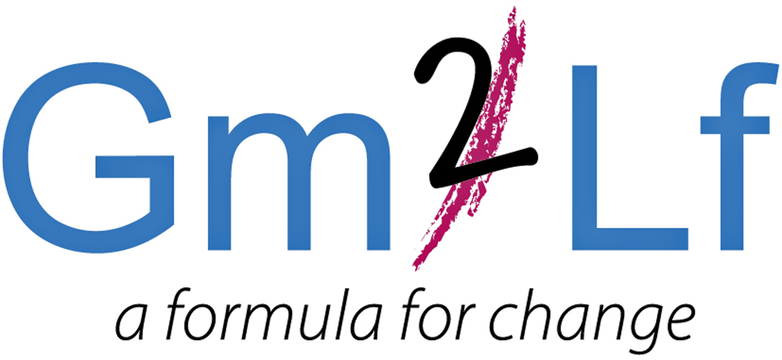
www.gm2lf.org

Grace Mary to Lion Farm (GM2LF) Big Local
Free Training Courses

In July, Sandwell College will be delivering Food Safety and Health and Safety training in Oldbury. GM2LF Big Local are offering free places and funding the course costs for people who live, work or volunteer in the Grace Mary to Lion Farm area.

Level 2 Award in Food Safety in Catering (QCF)
(A qualification aimed at caterers and other food handlers)

Friday 22nd July 2016. 9.00am - 3.30pm at Oakham Church, City Road, Oldbury, B69 1QZ
The qualification is intended for learners already working in catering and those who are preparing to work in the industry.
Learners gaining this qualification will know that food safety is the responsibility of everyone involved in the storage, preparation, cooking service and handling of food. Its topics are regarded by the Foods Standards Agency as being important to maintaining good practice in the production of safe food.

- Understand how individuals can take personal responsibility for food safety
- Understand the importance of keeping him/herself clean and hygienic
- Understand the importance of keeping the work areas clean and hygienic
- Understand the importance of keeping food safe

Cost
Free - if you live, work or volunteer in the GM2LF Big Local Area (Course would normally cost £30). Refundable £10 deposit required when booking. Please bring your own lunch.

HABC Level 2 Award in Health and Safety in the Workplace (QCF)

Tuesday 26th July 2016. 9.00am - 3.30pm at Darley House, Wallace Close, Oldbury, B69 1HT

This course has been accredited by the regulators of England and Wales (Ofqual and Qualification Wales) and is part of the Qualifications and Credit Framework (QCF).

- Understand roles and responsibilities for health, safety and welfare in the workplace
- Understand how risk assessments contribute to health and safety
- Understand how to identify and control the risks from common workplace hazards
- Know the procedures for responding to accidents and incidents in the workplace

Cost
Free - if you live, work or volunteer in the GM2LF Big Local Area (Course would normally cost £30). Refundable £10 deposit required when booking. Please bring your own lunch.

To book a place on either or both of these courses please complete the booking form below. Please also read the terms and conditions of booking.

www.gm2lf.org
GM2LF Big Local
Training Booking Form

Please complete this form and return with a £10 refundable deposit to Helen Trueman at GM2LF Big Local, Lion Farm Action Centre, Harry price House, Hartlebury Road, Oldbury. B69 1EQ.

Please note your deposit will be returned to you on confirmation that you have attended the course.

Course Date | Course Title | Cost | Please tick which you would like to attend
22/7/2016 | Level 2 Award in Food Safety in Catering (QCF | Free (£10 – refundable deposit)
26/7/2016 | HABC Level 2 Award in Health and Safety in the Workplace (QCF) | Free (£10 – refundable deposit)

Full Name:
Name of Organisation (if applicable)
Address: |  |  | Postcode:
Telephone: | E-mail:
Do you have any requirements? (e.g. access)

Please note tea and coffee will be provided, however please bring your own lunch as this will not be provided

Terms and Conditions of Booking
Booking
- No booking will be accepted without a booking form and accompanying £10 deposit(s) being returned to Helen Trueman, GM2LF Big Local at the above address.
- Deposits will be returned on confirmation you have attended the course
- Places are limited and if on receipt of your booking from the course is already fully booked your £10 deposit will be returned immediately.

Cancellation
- You should try to give as much notice as possible if you need to cancel your booking in order for your place to be given to someone else.
- If you fail to attend on the day without giving at least 24 hours’ prior notice your deposit will be kept in order to cover training costs incurred.

If you have any questions, please do not hesitate to contact Helen Trueman Email: helen.gm2lf@outlook.com or Tel: 07724 584241
Date Booking received |  | Initials
Deposit Received |  | Initials
Deposit Returned |  | Initials

For GM2LF Big Local use only:

