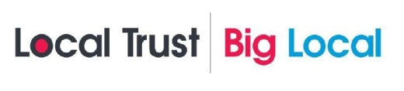
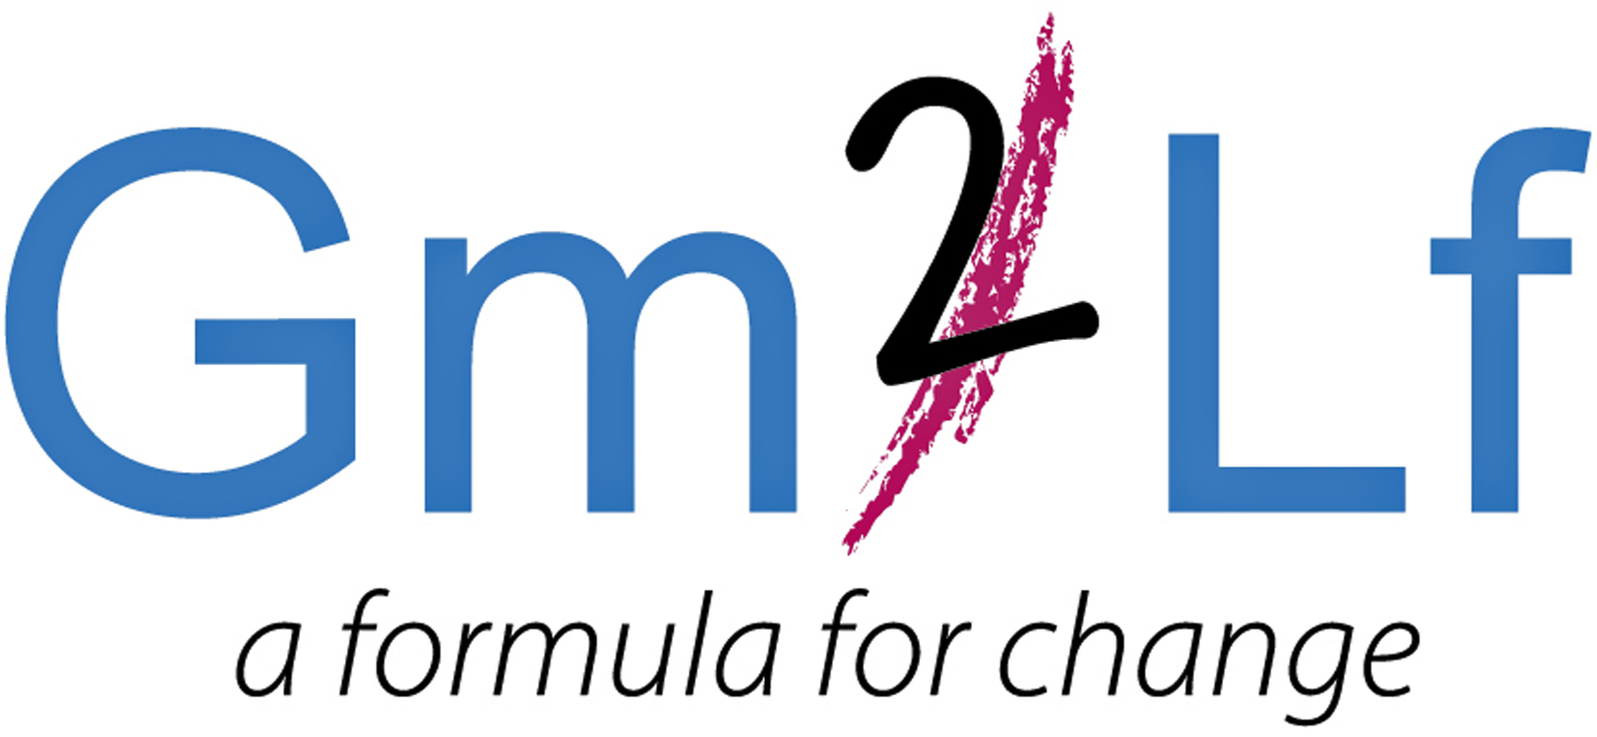

GM2LF Big Local ‘Our Environment’ Fund
Application Guidance

What is Grace Mary to Lion Farm (GM2LF) Big Local
Over the next 10 years £1m has been allocated to residents living in the area of Grace Mary to Lion Farm (GM2LF). The lottery money is being given out by Local Trust, a charity which delivers Big Local. Big Local is about bringing together all the local talent, ambitions, skills and energy from individuals, groups and organisations, who want to make the area of Grace Mary to Lion Farm an even better place to live.

Following consultation and research the five key themes that the GM2LF Big Local Partnership seeks to address in the area are:
- Our Community
- Our Environment
- Our Finance
- Our Learning
- Our Wellbeing

For more information, please read the GM2LF Big Local Plan which can be found at: www.biglocalmillionshare.org

‘Our Environment’ Fund
To support in addressing the priorities under the theme ‘Our Environment’ grants are currently available for not-for profit, voluntary and community groups, social enterprises and statutory agencies to deliver environmental projects in the Grace Mary to Lion Farm area. (Please see area map overleaf).

How much funding is available?
Not-for profit, voluntary and community groups, social enterprises and statutory agencies can bid for up to £1,000. Bids from Statutory agencies must be for activities which are additional to government funded services.

Grants are available for Environmental Projects which must demonstrate that they meet at least one of the following outcomes:
- There are more wildlife and/or sensory areas with easy access
- There are more people taking further pride in the area
- There are more safe spaces (park, play, allotments etc.)
- There are more areas of natural beauty

Funding can be used for either capital expenditure (e.g. equipment, furniture, materials, etc) or revenue costs (e.g. staff wages, venue hire costs and utilities costs). Funding can also be used for expanding existing activities or developing new activities that enhance the quality of resident’s lives in the Big Local area.

Funding is not available for individuals, however if you have a project idea and are not involved in a group, please contact the Partnership as there may be an opportunity to link in with other groups and projects.

Application Process
- Complete and submit the application form to the GM2LF Big Local Partnership
- Only one application per organisation can be made at any time.
- Applications have no deadline dates for submission. You can send your form at any time.
- Applications will be considered at a GM2LF Big Local Partnership meeting which are held monthly
- Successful and unsuccessful applicants for full applications will be notified within 14 days of the relevant Partnership Board Meeting
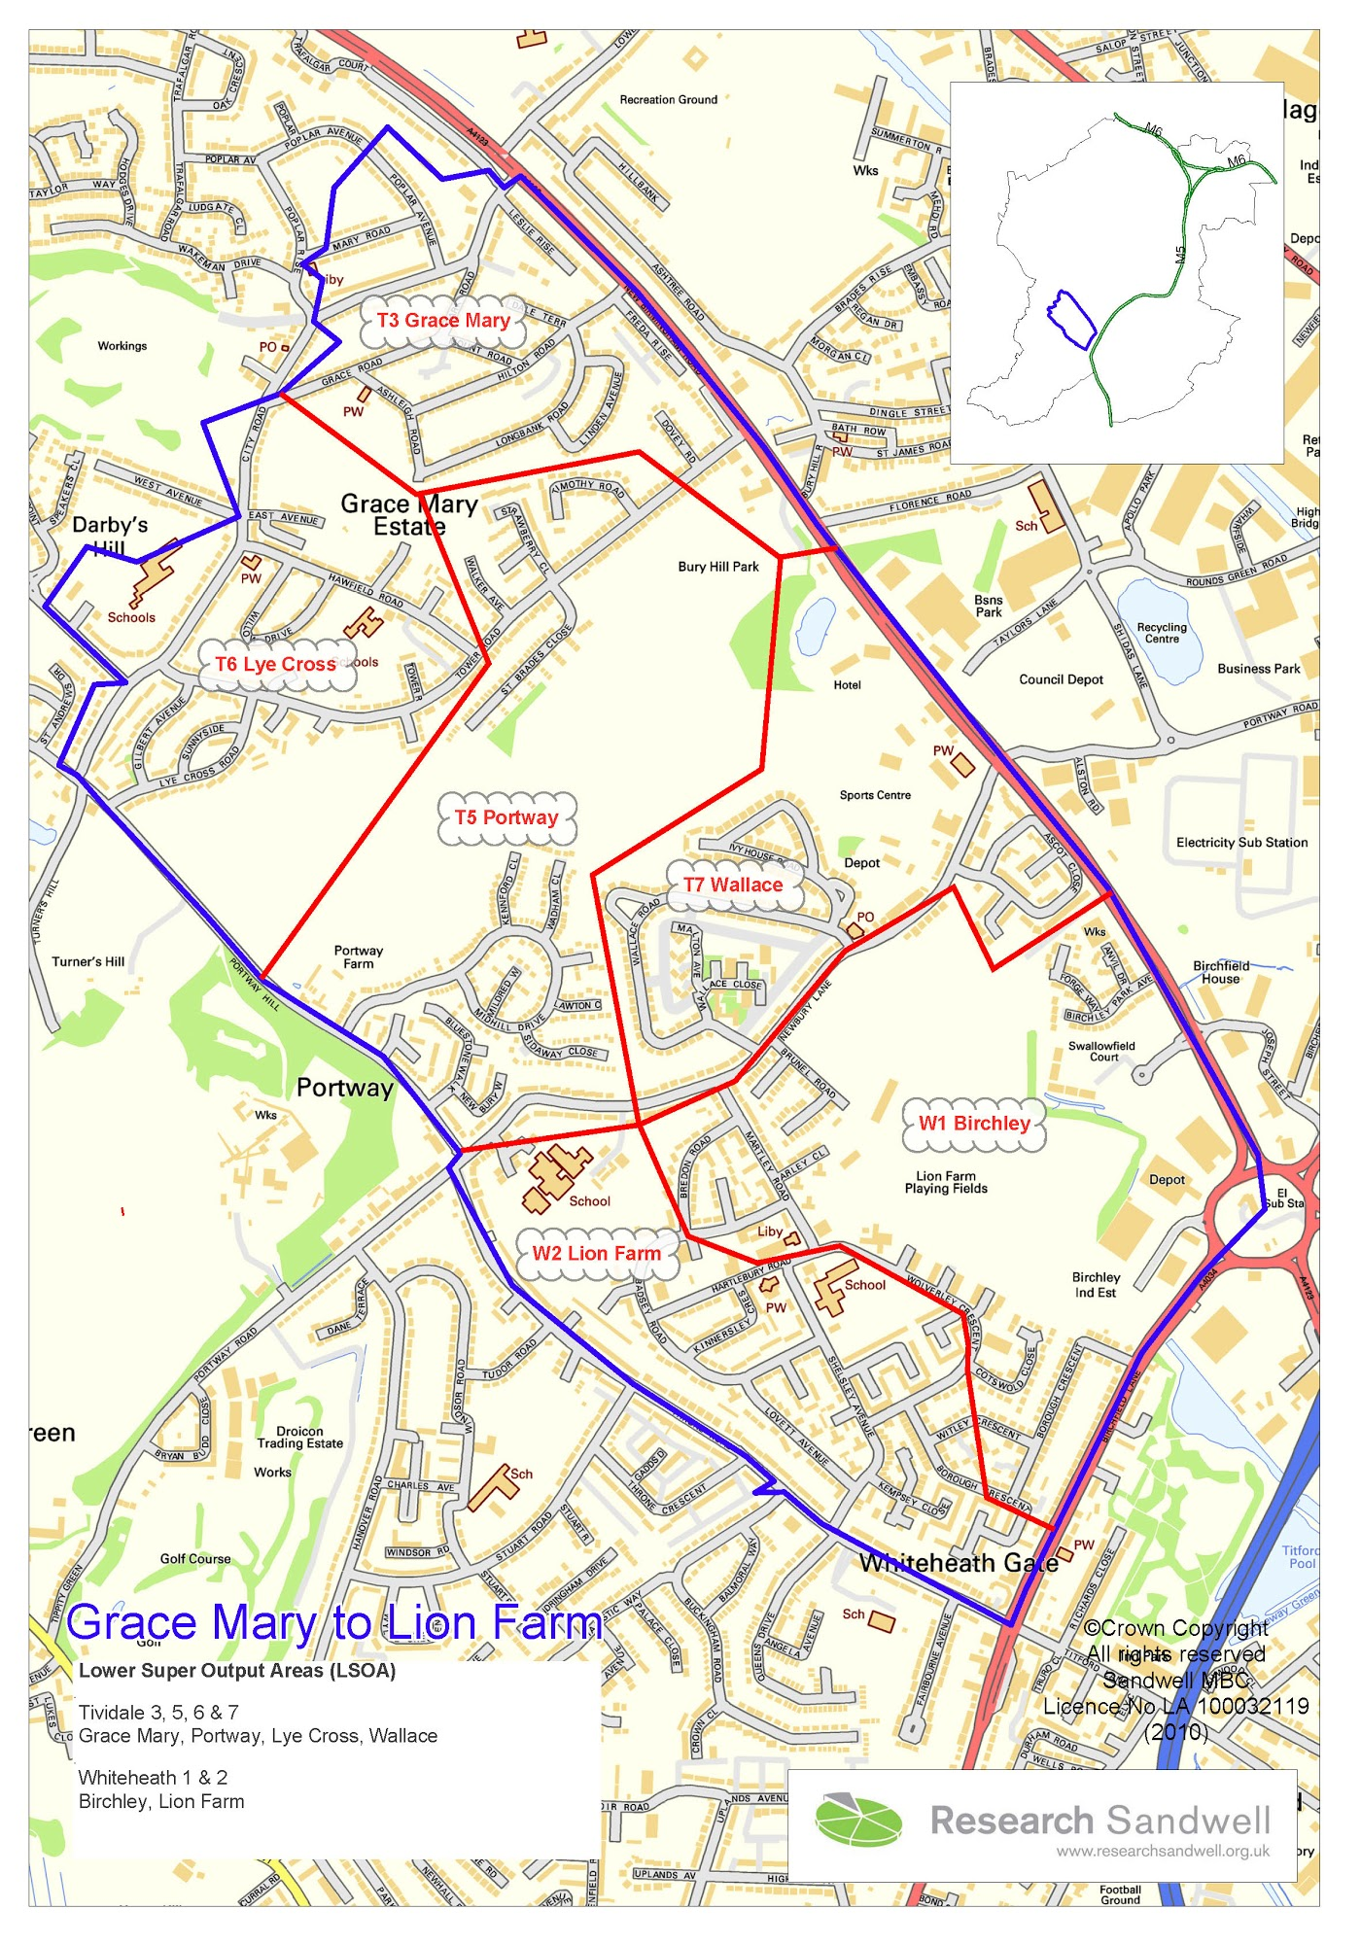
Important Points to Consider when Making an Application
- When applying for a grant, preference will be given to those applicants who can demonstrate how they meet the Big Local outcomes and benefit the residents of the Area.
- If your application involves contact with children or vulnerable adults, you will need to satisfy us that all the required DBS checks have been carried out.
- If applying towards a larger project all other funding must be in place.
- If your application is successful, you will be required to have spent the funding and complete a monitoring and evaluation form twelve months after the funding has been received. This form will include a spend breakdown, and we reserve the right to also ask for receipts/invoices.
- Successful applicants will also be expected to acknowledge and display GM2LF Big Local on all publicity relating to the funded project.
- Funding will not be provided on a retrospective basis and organisations should not commit themselves to the project before any final decision is made.
- If your application is successful, you will receive 2 copies of a Grant Agreement which will specify any conditions regarding your project. You will need to return a signed copy before any funds are released.
- Decisions made by the Partnership Board are final.
- If your application is successful, the grant will be issued via BACS by Sandwell Council of Voluntary Organisations (SCVO). (GM2LF Big Local’s Local Trusted Organisation).
- Please send your application form to: Kate Cross, Lion Farm Action Centre Harry Price House, Hartlebury Road, Oldbury, B69 1EQ. Alternatively email lionfarmactioncentre@yahoo.co.uk putting ‘Our Environment’ Fund in the header of the email.

Grace Mary to Lion Farm Big Local Area. (The area within the blue line)

