


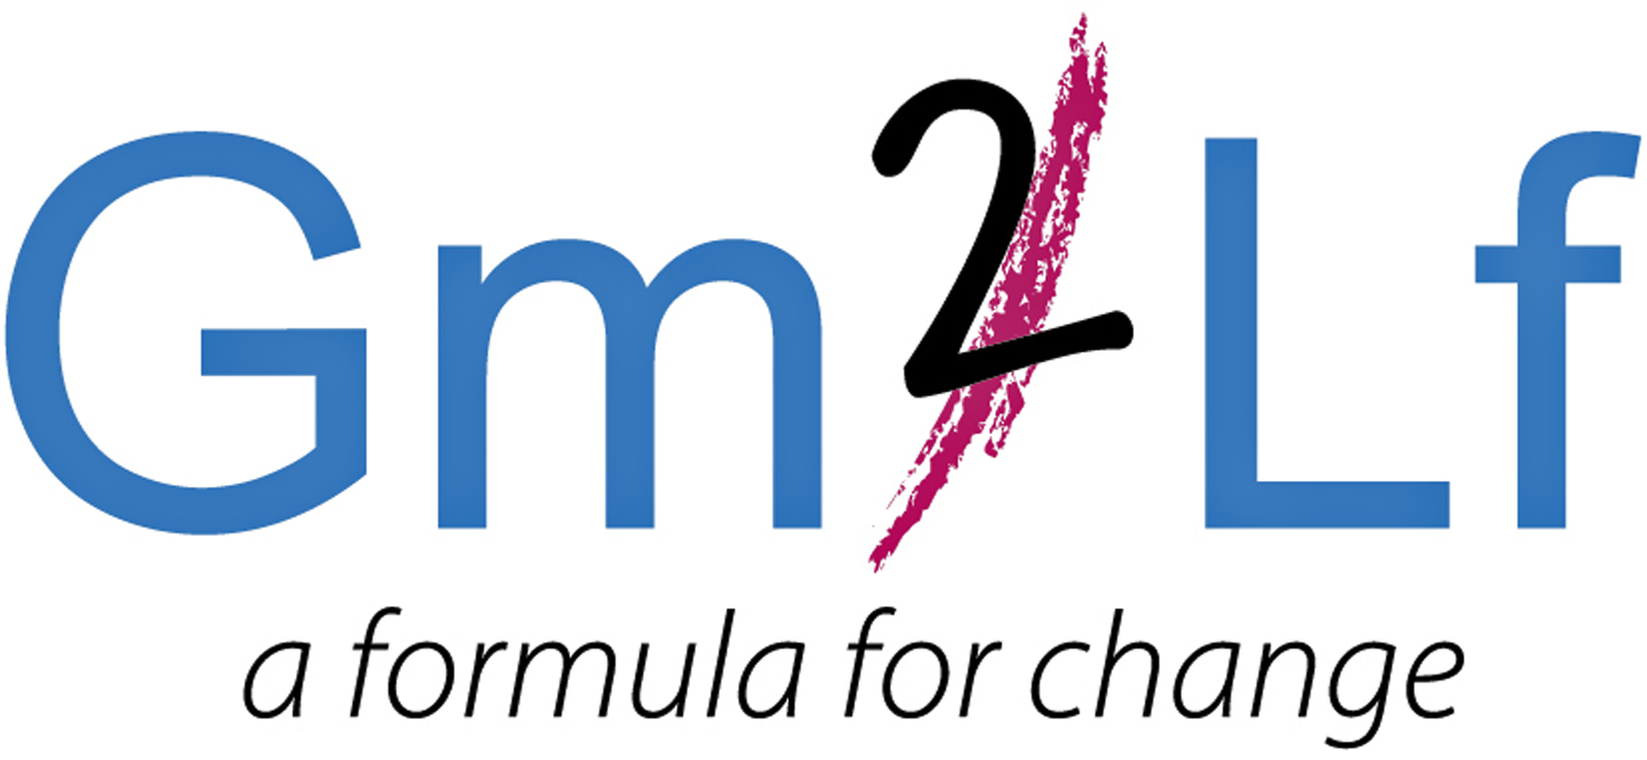

Big Local in Bloom Competition 2016
To enter, Please complete the application below:
Name _________________________________________
Address ____________________________________
____________________________________
____________________________________
Post Code ______________

Telephone ____________________________________
Email ____________________________________

I give permission for photos of my garden or balcony to be taken.
I am willing to be in the local press should I win the competition.
I agree that the judges’ decision is final
Signed _________________________________________
Print _________________________________________
Date _________________________________________

Your before photograph – Please let us know your availability
Please can you let us know which of the following dates are most convenient for you. (Our photographer will take no more than 10 minutes of your time). You will be contacted by telephone or email to confirm the exact time.

Please tick all boxes that apply:
19th April 11.00am-1.00pm 2.00pm-4.00pm
21st April 11.00am-1.00pm 2.00pm-4.00pm
22nd April 11.00am-1.00pm 2.00pm-4.00pm
None of the above

Please return this form to:
Kate Cross, C/O Lion Farm Action Centre, Harry Price House,
Hartlebury Road, Oldbury, B69 1EQ.
Email: kate.lfac@yahoo.co.uk
CLOSING DATE FOR APPLICATIONS
Friday 15th April 2016

