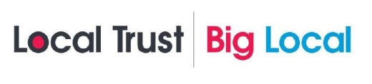
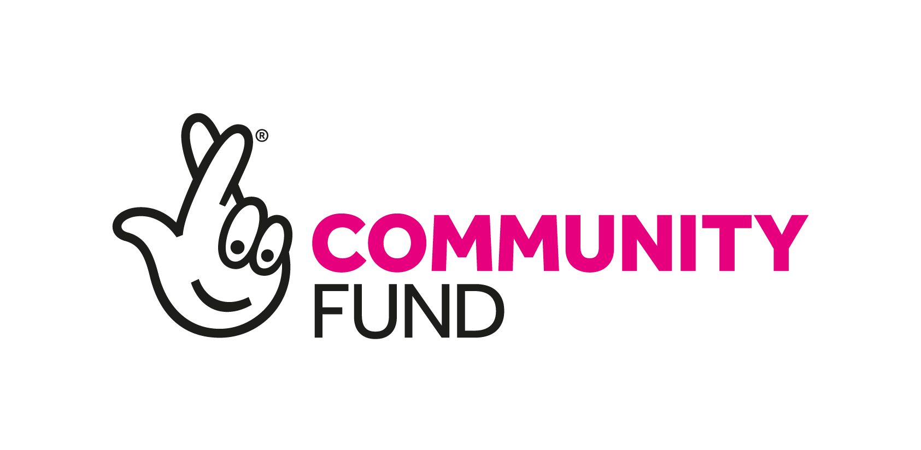
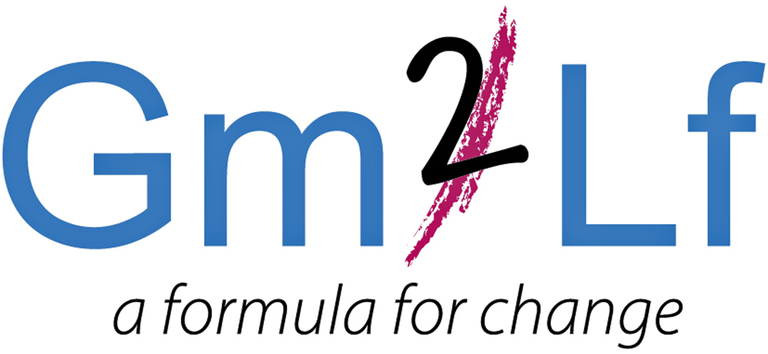
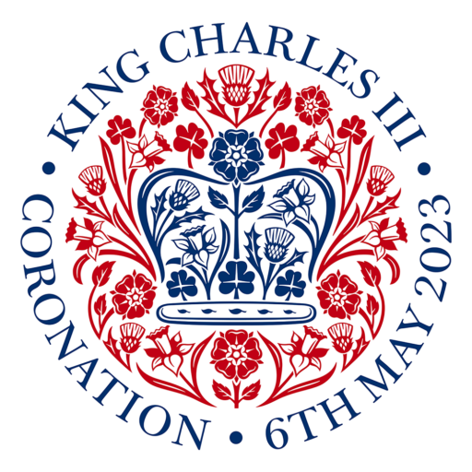

GM2LF Big Local ‘King’s Coronation Community Fund’
Application Guidance

What is Grace Mary to Lion Farm (GM2LF) Big Local
In 2014, £1m for a 10-year period was allocated to residents living in the area of Grace Mary to Lion Farm (GM2LF). The lottery money is being given out by Local Trust, a charity which delivers Big Local. Big Local is about bringing together all the local talent, ambitions, skills and energy from individuals, groups and organisations, who want to make the area of Grace Mary to Lion Farm an even better place to live.

Following consultation and research the five key priorities that the GM2LF Big Local Partnership seeks to address in the area are:
- Programme Support
- Bringing the Community Together
- Strengthening the Community
- Investing in Future Generations
- Supporting the Community Affected by Coronavirus/COVID-19

For more information, please read the current GM2LF Big Local Plan (2020 – 2025) which can be found at: www.gm2lf.org

King’s Coronation Community Fund
Grants are currently available to support events and activities that celebrate and commemorate The King’s Coronation on or around the weekend of 6 to 8 May 2023

Who can apply?
Not-for profit, voluntary and community groups and social enterprises active and delivering services in the Grace Mary to Lion Farm area. (Please see area map overleaf). Successful applicants must also agree to being part of a GM2LF Big Local King’s Coronation Showcase video by providing photos of their events/activities.

How much funding is available?
Groups can bid for up to £1,500. Successful projects will also be provided with a King’s Coronation starter party pack.

Grants are available for activities and projects which must demonstrate that they meet at least one of the following outcomes:

- Strengthen community connections.
- Increase the opportunities for people in the area.
- Enhance community spirit and sense of belonging.
- Improve the spaces and places that matter to communities.

Funding can be used for either capital expenditure (e.g. equipment, furniture, materials, etc) or revenue costs (e.g. staff wages, venue hire costs and utilities costs). Successful projects must be directly related to The King's Coronation and demonstrate appropriate community benefit and/or community input.

Applicants are encouraged to visit the national website for the King's Coronation at: https://coronation.gov.uk/get-involved/

Funding is not available for individuals.

Application Process
- Complete and submit the application form to the GM2LF Big Local Partnership.
- Only one application per organisation can be made at any time.
- Deadline for applications is Monday 3rd April 2023.
- Applications will be assessed by a Funding Steering Group and decided by the GM2LF Big Local Partnership.
- Successful and unsuccessful applicants will be notified within 14 days of submission.
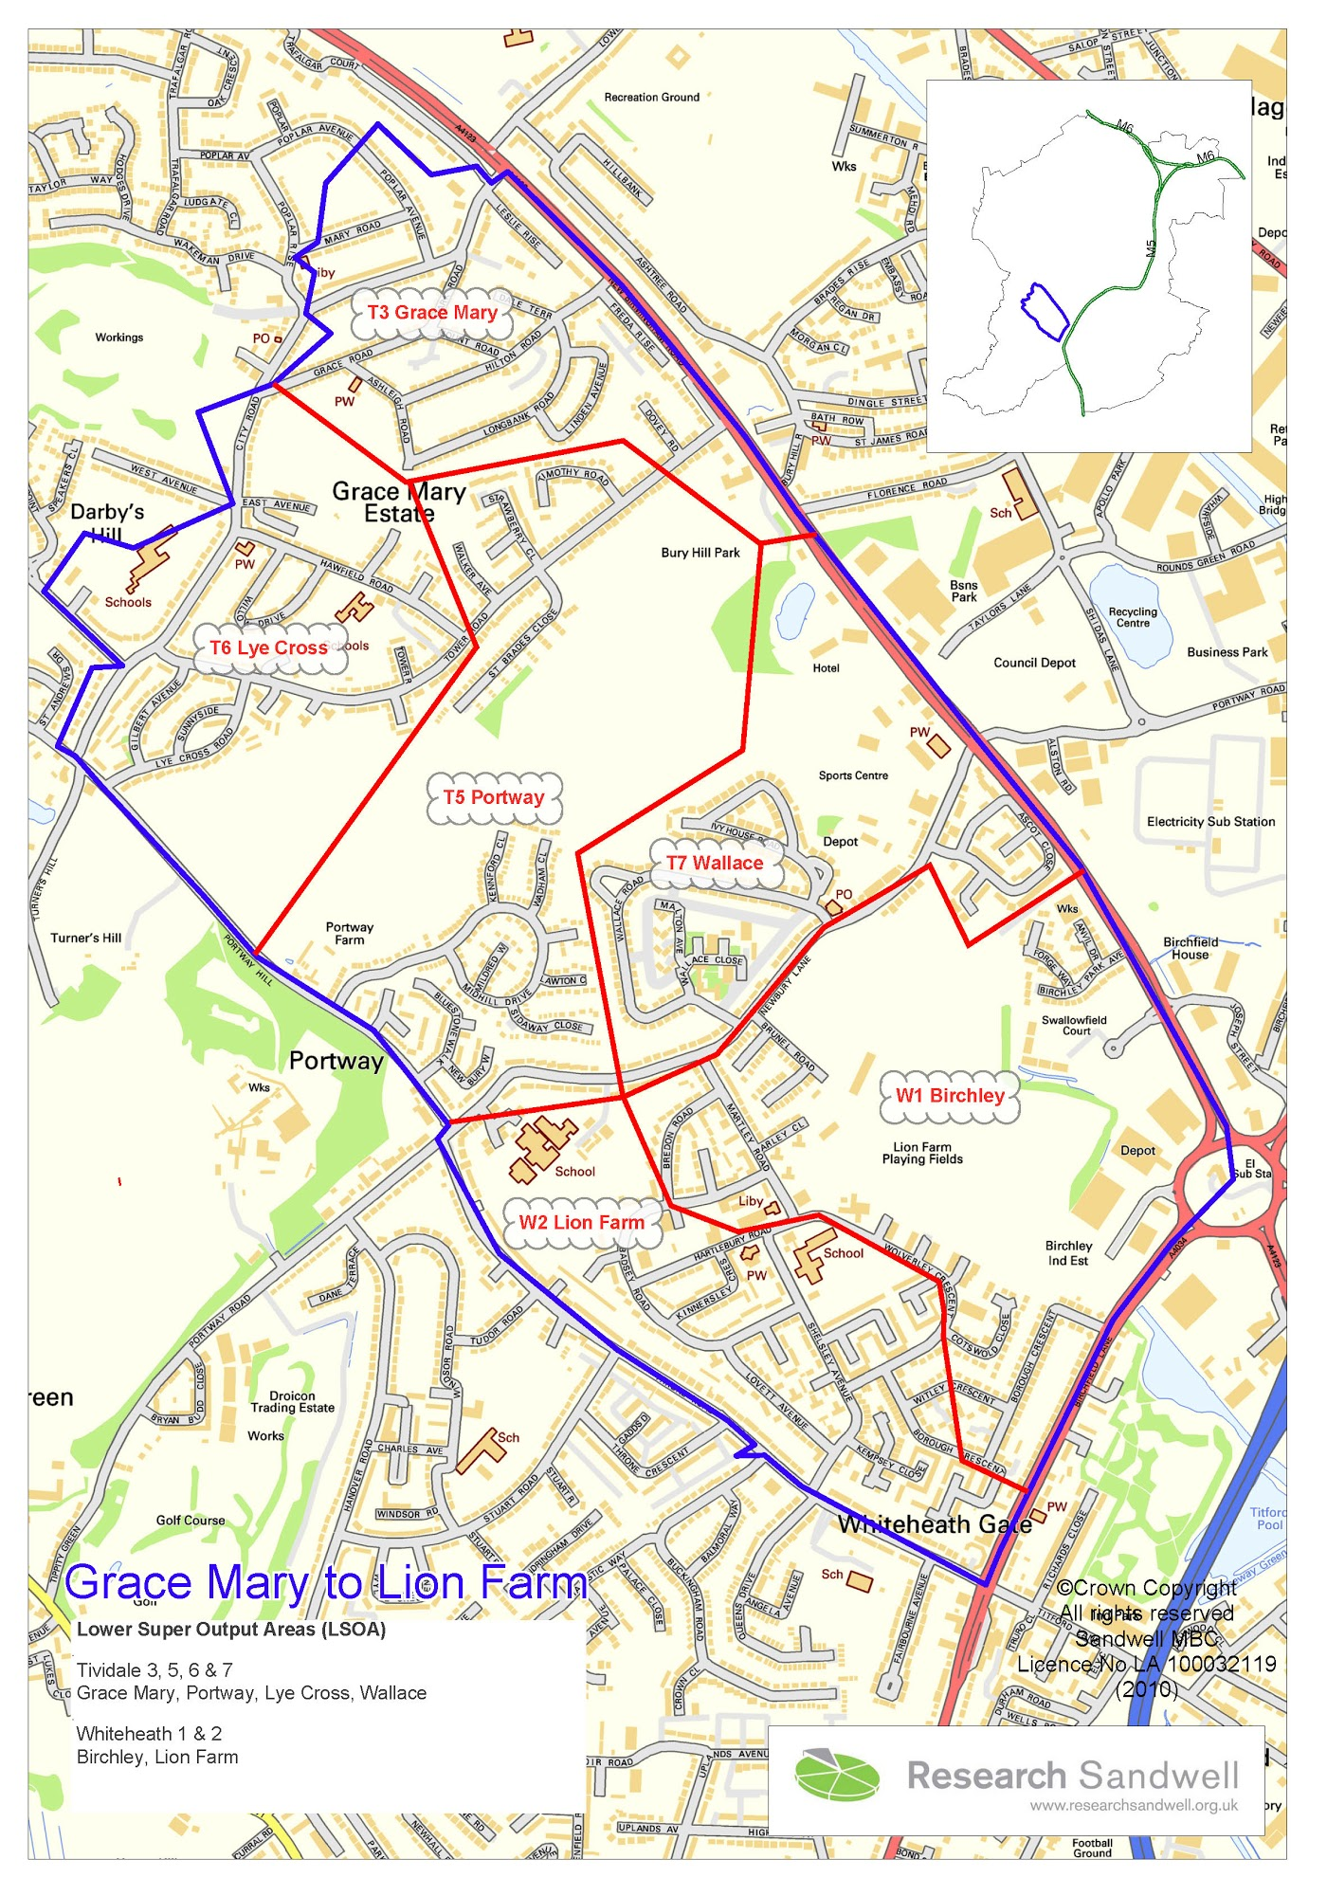
Important Points to Consider when Making an Application
- When applying for a grant, preference will be given to those applicants who can demonstrate how they meet the Big Local outcomes and benefit the residents of the Area.
- If your application involves contact with children and/or vulnerable adults, you will need to satisfy us that all the required DBS checks have been carried out.
- If applying towards a larger project all other funding must be in place or you must evidence how you intend to secure other funding.
- If your application is successful, you will be required to have spent the funding and complete a monitoring and evaluation form six months after the funding has been received. This form will include a spend breakdown, and we reserve the right to also ask for receipts/invoices.
- Successful applicants will be expected to acknowledge and display GM2LF Big Local on all publicity relating to the funded project.
- Successful applicants will also be expected to take part in a GM2LF Big Local King’s Coronation showcase video and must submit photos no later than 5 days after the events/activities.
- Funding will not be provided on a retrospective basis and organisations should not commit themselves to the project before any final decision is made.
- If your application is successful, you will receive two copies of a Grant Agreement which will specify any conditions regarding your project. You will need to return a signed copy before any funds are released.
- Decisions made by the Partnership Board are final.
- If your application is successful, the grant will be issued via BACS by Sandwell Council of Voluntary Organisations (SCVO). (GM2LF Big Local’s Local Trusted Organisation).
- Please send your application form to: Helen Trueman by email helen.gm2lf@outlook.com
or by post to Lion Farm Action Centre, The Vicarage, Shelsley Avenue, Oldbury. B69 1BG.

Grace Mary to Lion Farm Big Local Area. (The area within the blue line)

