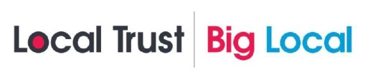
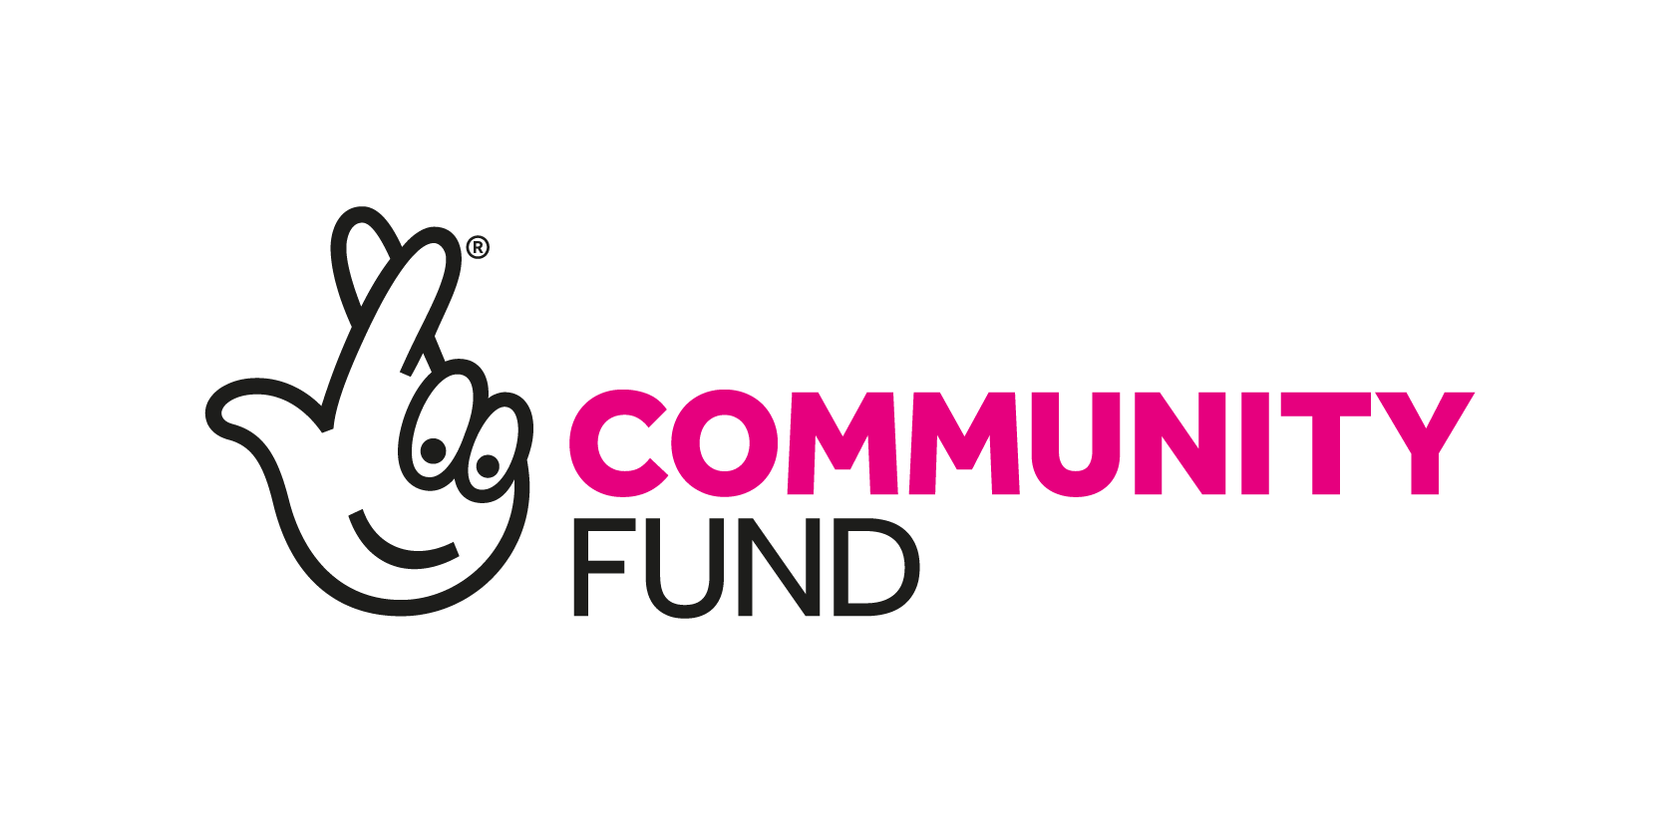
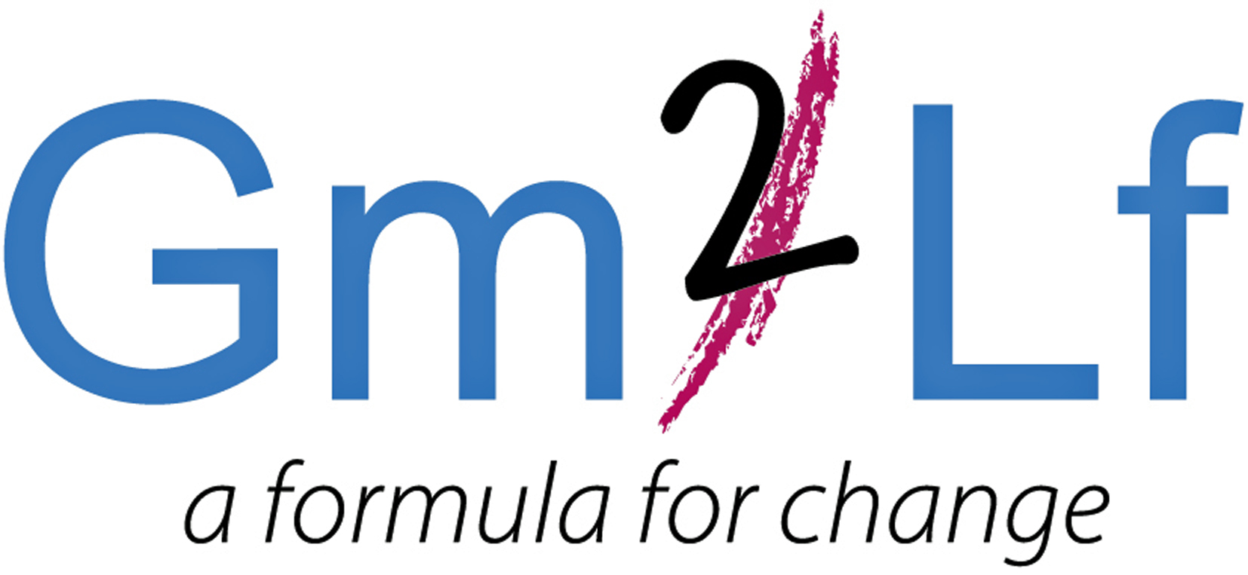

GM2LF Big Local Community Hubs Development Fund
Application Guidance

What is Grace Mary to Lion Farm (GM2LF) Big Local
In 2014, £1m for a 10-year period was allocated to residents living in the area of Grace Mary to Lion Farm (GM2LF). The lottery money is being given out by Local Trust, a charity which delivers Big Local. Big Local is about bringing together all the local talent, ambitions, skills and energy from individuals, groups and organisations, who want to make the area of Grace Mary to Lion Farm an even better place to live.

Following consultation and research the five key priorities that the GM2LF Big Local Partnership seeks to address in the area are:
- Programme Support
- Bringing the Community Together
- Strengthening the Community
- Investing in Future Generations
- Supporting the Community Affected by Coronavirus/COVID-19

For more information, please read the current GM2LF Big Local Plan (2020 – 2025) which can be found at: www.gm2lf.org

Community Hubs Development Fund
To support in addressing the priority Bringing the Community Together, grants are currently available for not-for profit, voluntary and community groups and social enterprises. The funding is primarily for the development of community buildings located and delivering services in the Grace Mary to Lion Farm area. (Please see area map overleaf).

How much funding is available?
Groups can bid for up to £5,000

Grants are available for activities and projects which must demonstrate that they meet at least one of the following outcomes:

- Bring people together and build strong relationships in and across communities
- Improve the places and spaces that matter to communities
- Enhance community spirit where neighbours look out and care for one another
- Increase opportunities for communities to come together to actively participate in the GM2LF Big Local

Funding can be used for either capital expenditure (e.g. equipment, furniture, materials, etc) or revenue costs (e.g. staff wages, venue hire costs and utilities costs). Funding can be used for expanding existing activities or developing new activities that enhance the quality of resident’s lives in the Big Local area.

Funding is not available for individuals, however if you have an exciting project idea and are not involved in a group, please complete an expression of interest form. The partnership would like to hear from you and there may be an opportunity to link in with other groups and projects.

Application Process
- Complete and submit the application form to the GM2LF Big Local Partnership.
- Only one application per organisation can be made at any time.
- Applications have no deadline dates for submission. You can send your form at any time.
- Applications will be considered at a GM2LF Big Local Partnership meeting which are held monthly.
- You may apply for any amount of up to £5,000 within the period of August 2020 – 31st May 2021.
- Successful and unsuccessful applicants for full applications will be notified within 14 days of the relevant Partnership Board Meeting.

Important Points to Consider when Making an Application
- When applying for a grant, preference will be given to those applicants who can demonstrate how they meet the Big Local outcomes and benefit the residents of the Area.
- If your application involves contact with children and/or vulnerable adults you will need to satisfy us that all the required DBS checks have been carried out.
- If applying towards a larger project all other funding must be in place or you must evidence how you intend to secure other funding.
- If your application is successful you will be required to have spent the funding and complete a monitoring and evaluation form twelve months after the funding has been received. This form will include a spend breakdown, and we reserve the right to also ask for receipts/invoices.
- Successful applicants will be expected to acknowledge and display GM2LF Big Local on all publicity relating to the funded project.
- If the grant is awarded for a community building, successful applicants will also be expected to display a GM2LF Big Local Funded plaque.
- Funding will not be provided on a retrospective basis and organisations should not commit themselves to the project before any final decision is made.
- If your application is successful you will receive two copies of a Grant Agreement which will specify any conditions regarding your project. You will need to return a signed copy before any funds are released.
- Decisions made by the Partnership Board are final.
- If your application is successful the grant will be issued via BACS by Sandwell Council of Voluntary Organisations (SCVO). (GM2LF Big Local’s Local Trusted Organisation).
- Please send your application form to: Helen Trueman by email helen.gm2lf@outlook.com
or by post to Lion Farm Action Centre, The Vicarage, Shelsley Avenue, Oldbury. B69 1BG.
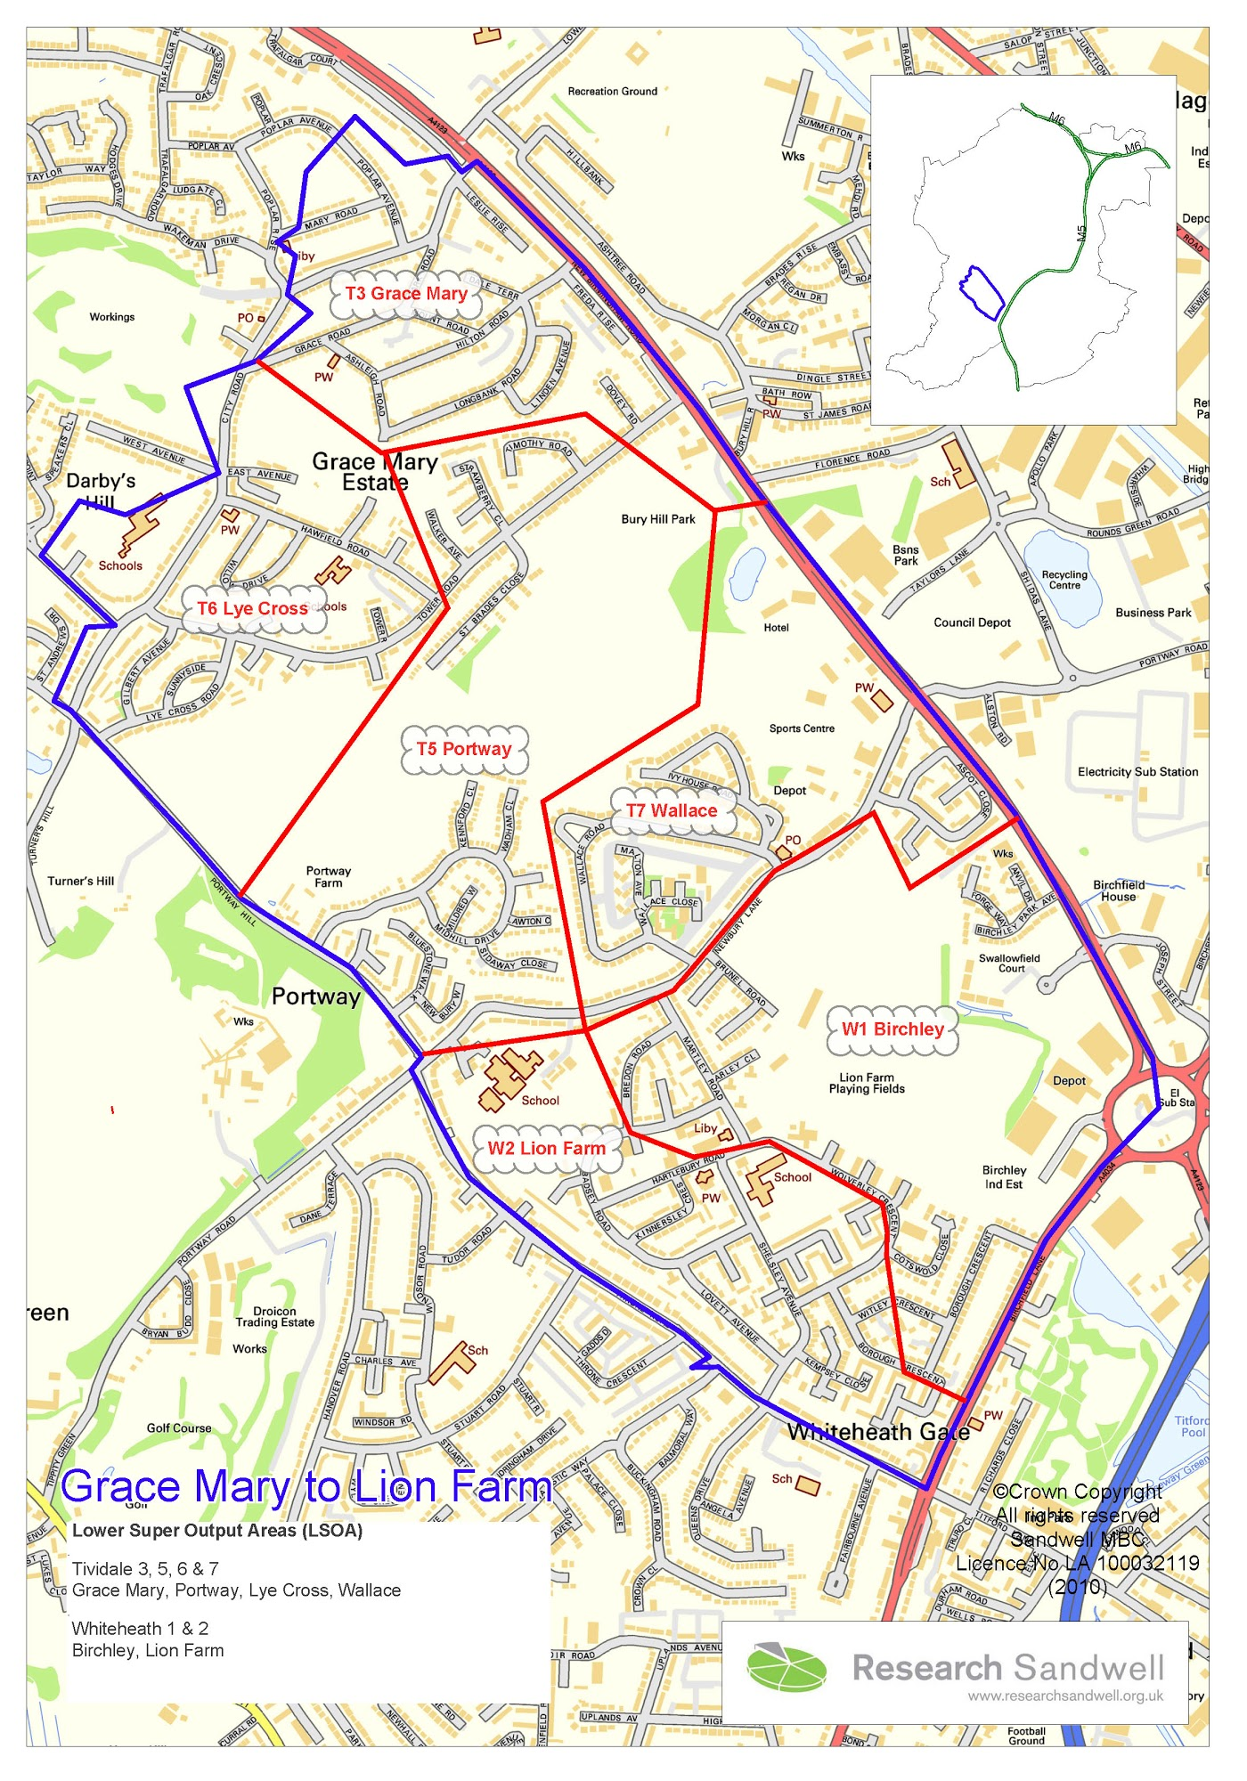

Grace Mary to Lion Farm Big Local Area. (The area within the blue line)

