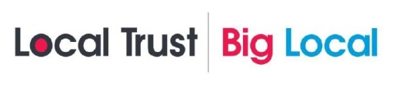
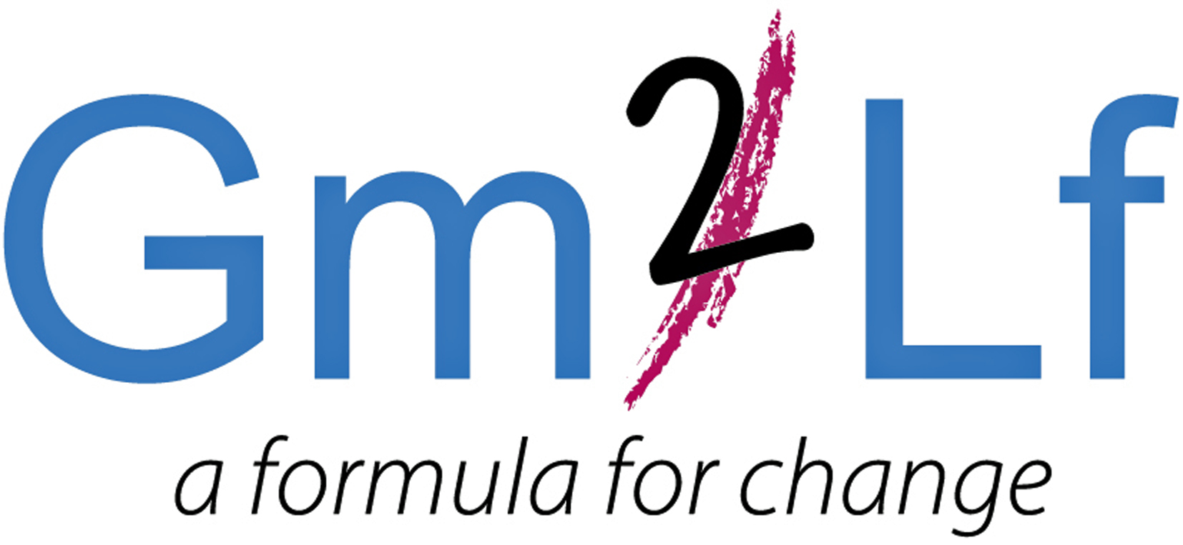
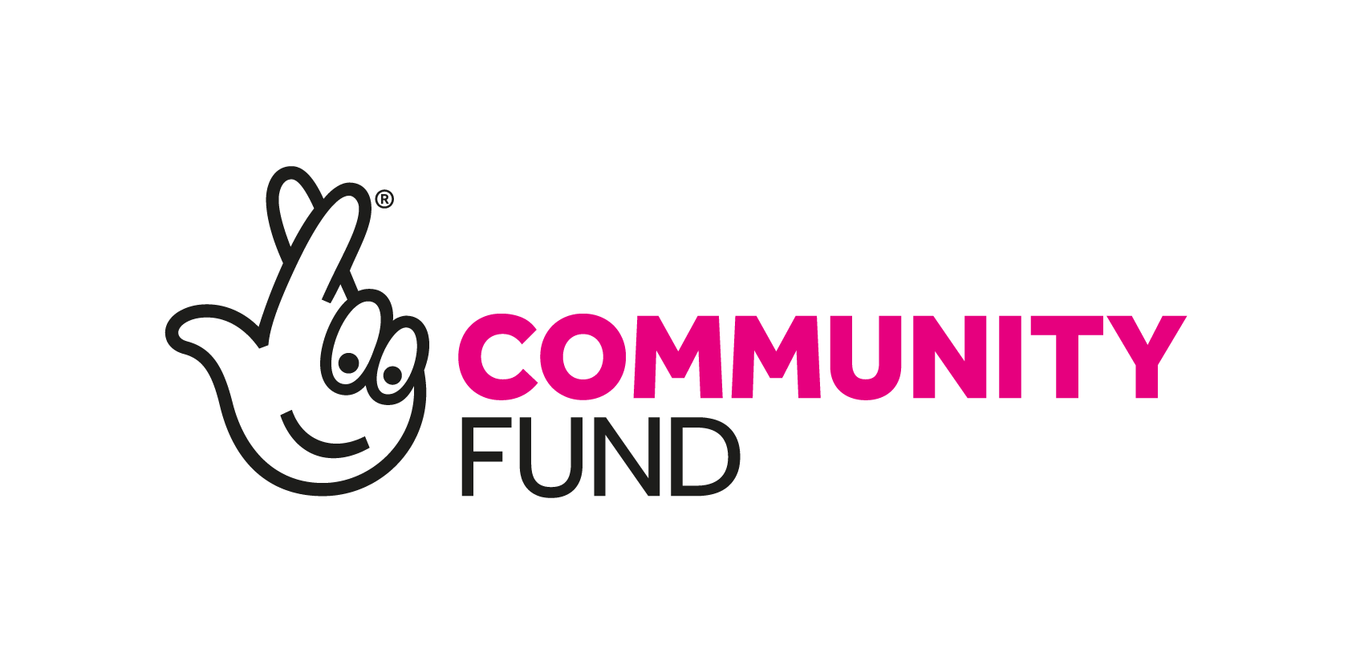
GM2LF Big Local ‘School Impact Fund’
Application Guidance

What is Grace Mary to Lion Farm (GM2LF) Big Local
In 2014, £1m over 10 years was allocated to residents living in the area of Grace Mary to Lion Farm (GM2LF). The lottery money is being given out by Local Trust, a charity which delivers Big Local. Big Local is about bringing together all the local talent, ambitions, skills and energy from individuals, groups and organisations, who want to make the area of Grace Mary to Lion Farm an even better place to live.

Following consultation and research the five key themes that the GM2LF Big Local Partnership seeks to address in the area are:
- Our Community
- Our Environment
- Our Finance
- Our Learning
- Our Wellbeing

For more information, please read the 2017 – 2020 GM2LF Big Local Plan which can be found at: www.gm2lf.org

‘School Impact’ Fund
To support in addressing the priorities under some of the themes mentioned above the ‘School Impact Fund’ is currently available for schools based in the Grace Mary to Lion Farm area. (Please see area map overleaf).

How much funding is available?
Schools can bid for up to £12,000. Bids must be for activities or projects which are additional to government funded services.

Grants are available for projects which must demonstrate that they meet at least three of the following outcomes:
- More safe spaces
- More wildlife and sensory areas with easy access
- More people taking more pride in the area
- There is an increased access to learning for all
- There is an increase in informal learning with more one to one support with children and young people
- People are taking up more exercise and/or more healthier eating
- There is an increased support for people with emotional and mental needs
- People feel less isolated and more connected with their neighbours
- There is an increased opportunity for people to try something completely new

Funding can be used for either capital expenditure (e.g. equipment, furniture, materials, etc) or revenue costs (e.g. venue hire costs and utilities costs). Funding can also be used for new or expanding existing activities or developing new activities that enhance the quality of resident’s lives in the Big Local area.

Application Process
- Complete and submit the application form to the GM2LF Big Local Partnership
- Only one application per school can be made at any time.
- Applications have no deadline dates for submission. You can send your form at any time.
- You may apply for any amount of up to £12,000 within the period of April 2019 – 28th February 2020.
- Applications will be considered at a GM2LF Big Local Partnership meeting which are held monthly
- Successful and unsuccessful applicants for full applications will be notified within 14 days of the relevant Partnership Board Meeting

Important Points to Consider when Making an Application
- When applying for a grant, preference will be given to those applicants who can demonstrate how they meet the Big Local outcomes and benefit the residents of the Area.
- Applications must demonstrate how they will contribute to raising the profile of the GM2LF Big Local and helping to engage local residents
- If your application involves contact with children or vulnerable adults, you will need to satisfy us that all the required DBS checks have been carried out.
- If applying towards a larger project all other funding must be in place.
- If your application is successful, you will be required to have spent the funding and complete a monitoring and evaluation form twelve months after the funding has been received. This form will include a spend breakdown, and we reserve the right to also ask for receipts/invoices.
- Successful applicants will also be expected to acknowledge and display GM2LF Big Local on all publicity relating to the funded project.
- Successful applicants will also be expected to display a ‘GM2LF Big Local Funded’ plaque.
- Funding will not be provided on a retrospective basis and schools should not commit themselves to the project before any final decision is made.
- If your application is successful, you will receive 2 copies of a Grant Agreement which will specify any conditions regarding your project. You will need to return a signed copy before any funds are released.
- Decisions made by the Partnership Board are final.
- If your application is successful, the grant will be issued via BACS by Sandwell Council of Voluntary Organisations (SCVO). (GM2LF Big Local’s Local Trusted Organisation).
- Please send your application form to: Helen Trueman, Lion Farm Action Centre, The Vicarage, Shelsley Avenue B69 1BG. Alternatively email helen.gm2lf@outlook.com putting ‘School Impact Fund’ in the header of the email.

Grace Mary to Lion Farm Big Local Area. (The area within the blue line)

